<https://developer.android.com/design/material/index.html>

<http://www.google.com/design/spec/material-design/introduction.html>

<https://developer.android.com/training/material/lists-cards.html>

[Optimizing your UI](http://developer.android.com/tools/debugging/debugging-ui.html)

<http://developer.android.com/tools/debugging/debugging-ui.html>

<http://developer.android.com/tools/help/hierarchy-viewer.html>

<http://developer.android.com/tools/help/lint.html>

Note: Hierarchy Viewer is in sdk/tools/hierarchyviewer. Alternativly you can open it by going to the Android Device Monitor and then clicking the Hierarchy Viewer button.

Hierarchy Viewer only works by default with phones running a developer version of the Android OS. If your phone is not a developer phone, you have a few options:

1. If you have a phone running Jellybean or higher, you can simply add the environment variable ANDROID\_HVPROTO with the value ddm:

ANDROID\_HVPROTO=ddm

1. You can run Hierarchy Viewer on an emulated phone.
2. Or you can use use the [ViewServer](https://github.com/romainguy/ViewServer" \t "_blank) library to get Hierarchy Viewer working on a non-developer, pre Jellybean phone.

Height and width

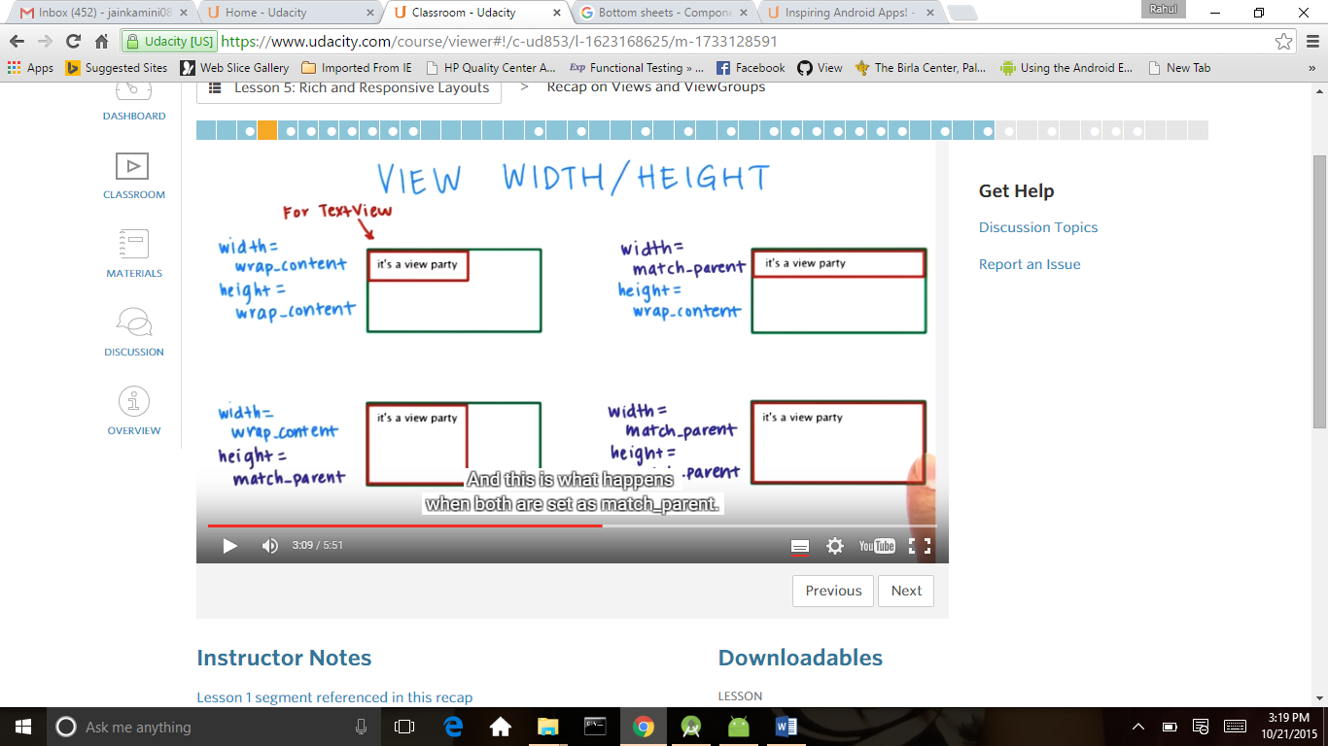

Gravity

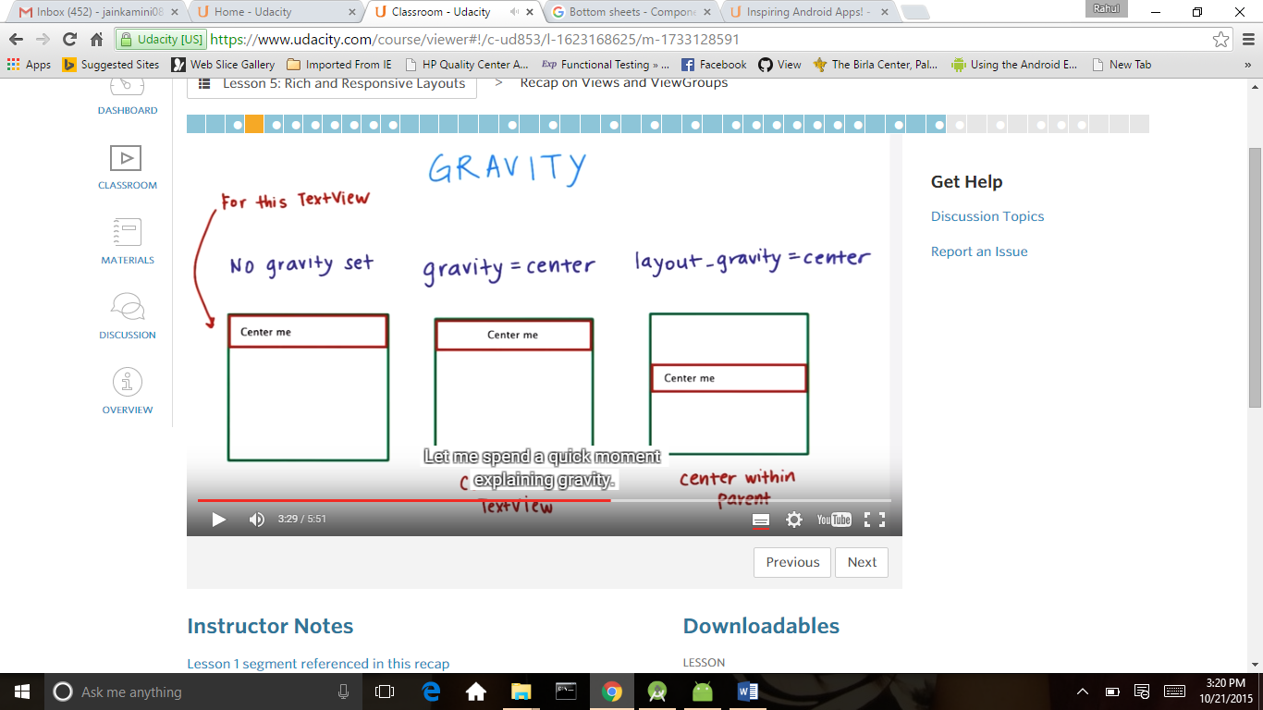

Padding and margin

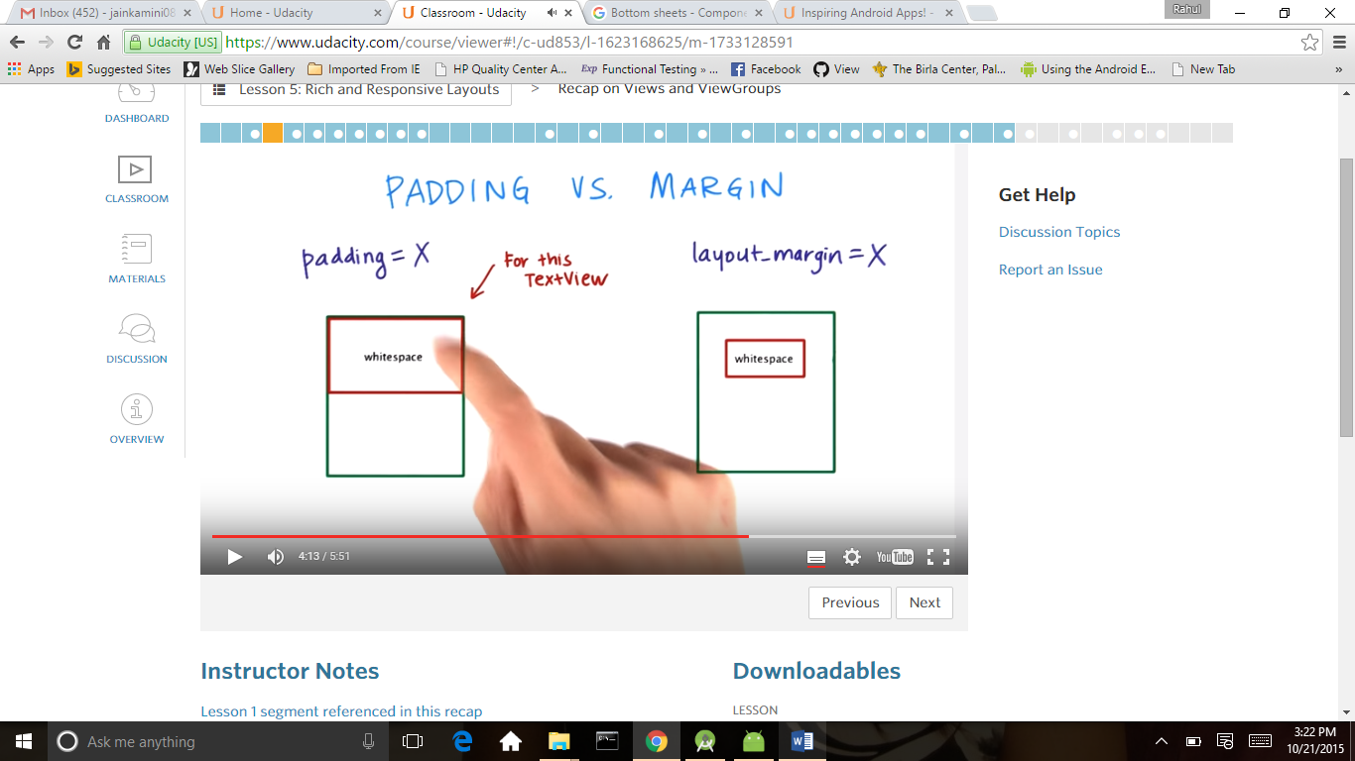

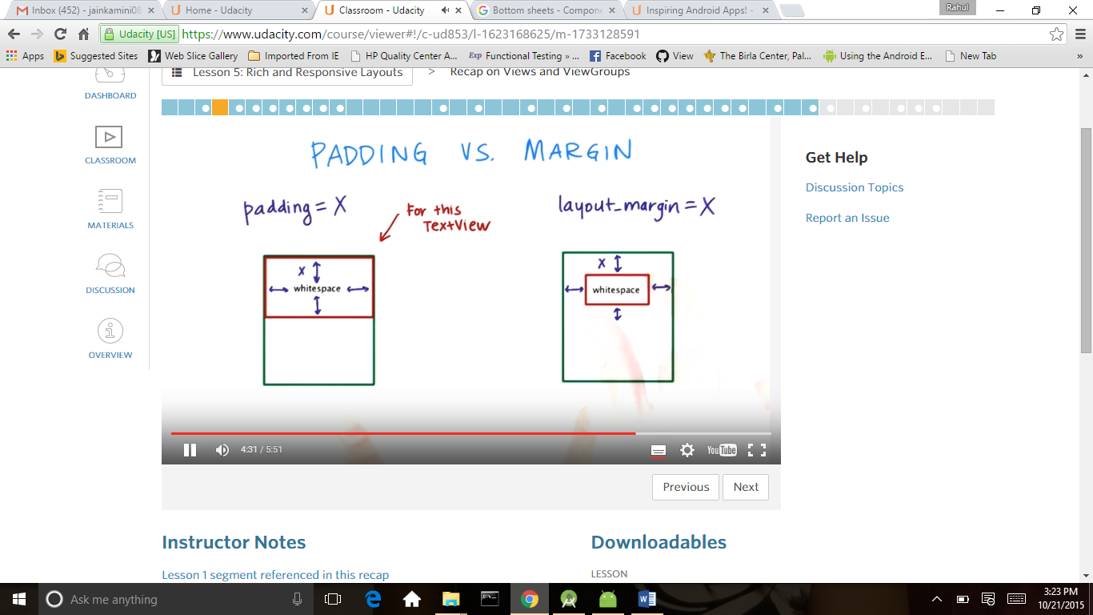

Visibility of all views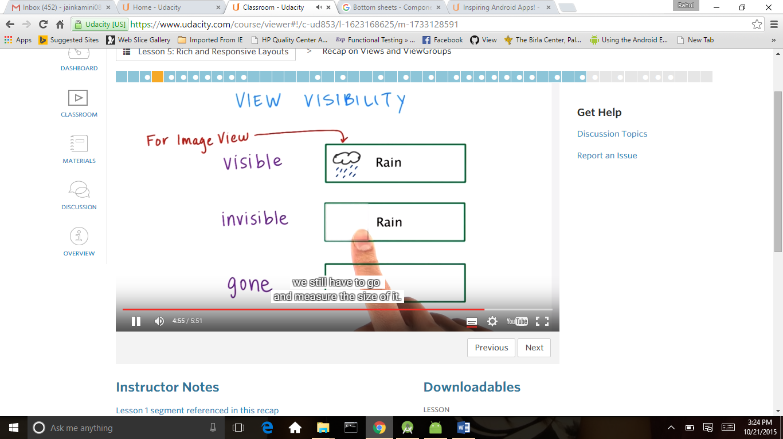

For tablet

<http://developer.android.com/distribute/essentials/quality/tablets.html>

<https://www.google.com/design/spec/layout/principles.html>

<http://developer.android.com/guide/practices/screens_support.html#dips-pels>

<http://developer.android.com/guide/practices/screens_support.html#ConfigurationExamples>

[ListView choice mode](http://developer.android.com/reference/android/widget/AbsListView.html#attr_android:choiceMode)

<http://developer.android.com/reference/android/widget/AbsListView.html#attr_android:choiceMode>

<http://developer.android.com/guide/topics/ui/themes.html>

<http://developer.android.com/guide/topics/resources/drawable-resource.html#StateList>

Use Layout Aliases

<http://developer.android.com/training/multiscreen/screensizes.html#TaskUseAliasFilters>

action bar

<http://developer.android.com/reference/android/R.attr.html#displayOptions>

<http://developer.android.com/design/patterns/actionbar.html>

<http://developer.android.com/guide/topics/ui/actionbar.html>

Typography

<https://www.google.com/design/spec/style/typography.html#typography-styles>

<http://developer.android.com/guide/topics/resources/more-resources.html#Color>

# **Accessibility**

<http://developer.android.com/guide/topics/ui/accessibility/index.html>

<http://developer.android.com/guide/topics/ui/accessibility/apps.html>

<http://developer.android.com/guide/topics/ui/accessibility/checklist.html>

http://developer.android.com/guide/topics/ui/accessibility/services.html

